**Software Engineering Report**

**Group 9**

**Name: Harry Langham**

**ID: 15624847**

Group Members:

* Luke Sewell
* Callum King
* Suki Harrison
* Harry Langham

Team Roles:

* Harry – ScrumMaster
* Callum – Development Team/UI designer
* Luke – Development Team/UX designer
* Suki – Development Team

Project description:

1. Application to generate track recommendations from Spotify based that day’s news. Extract terms from news source. Use those terms to get recommended tracks from Spotify (track of the day, alternative (i.e. opposite to terms gathered), etc.

See: https://developer.spotify.com , <https://newsapi.org>,

We as a group decided to choose the first project (Spotify application). We will be creating this application using a SCRUM approach. Scrum is “a framework within which people can address complex adaptive problems, while productively and creatively delivering products of the highest possible value.” (Scrum.org, 2019). Scrum as a methodology is based on constant feedback and contact between members of the development team within Sprint reviews and retrospectives.

“Each Sprint may be considered a project with no more than a one-month horizon. Like projects, sprints are used to accomplish something. Each sprint has a goal of what is to be built, a design and flexible plan that will guide building, the work, and the resultant product increment.” (Scrum.org, 2019).

Within this project, the group have agreed upon 5 sprints lasting 1 week each, this will allow enough time to complete all of the objectives (PBI’s) specified at the start of each sprint Each Sprint review has been recorded and will be presented in this report.

To start the Scrum process, several elements need to be obtained from the client. These are User stories and Product Backlog Items.

**User Stories:**

1. As a politician I would like song recommendations based upon key political news terms as I haven’t got enough time to search through twitter/news in the mornings for my job and afternoon Spotify listening sessions.
2. As a young adult interested in world news I would like recommendations based upon key news stories so I can listen to Spotify as it combines my two interests.
3. As a person interested in alternate music I would like recommendations on Spotify based on popular news story news terms so that I can find new artists and albums to add to my collection.
4. As a news entertainment host, I would like to get Spotify recommendations based upon key news terms as I have a twitter account where I post songs based upon breaking news to my audience and to use in my 5 minute music/news segment on Channel 4.
5. As a sports and music fan, I would like to receive Spotify recommendations based upon the biggest sports terms at the time.

**Product Backlog Items:**

|  |  |  |  |
| --- | --- | --- | --- |
| ID | Task | Time Estimate | Priority |
| 1 | Obtain API key from News API. | 1 | 9 |
| 2 | Obtain API key from Spotify API. | 1 | 6 |
| 3 | Use News API to filter through key terms in weekly news topics. | 4 | 7 |
| 4 | Use Spotify API to filter recommendations using key words. | 4 | 4 |
| 5 | Research filtering key terms from News API to Spotify API. | 4 | 7 |
| 6 | Filter news terms from news API and send through to Spotify to obtain Songs and artists. | 5 | 2 |
| 7 | Create menu to allow the user to select different news options. | 4 | 3 |
| 8 | Add options to the menu for users to select where they want their news from. | 2 | 2 |
| 9 | Obtain more specific key terms to search for in the Spotify API using frequency analysis. | 6 | 5 |
| 10 | Process the returned news data to remove irrelevant characters for frequency analysis. | 2 | 6 |
| 11 | Add options to the menu to allow the user to select different categories of news. | 2 | 2 |
| 12 | Testing and bug fixing of the application. | Unknown | 1 |

For time estimate 1 point = 30 minutes

Priorities are in logical order. This logical order has the items with the least knowledge having higher priority such as obtaining the API Keys as they need little work to complete, they also generally have a smaller estimated time remaining.

**Sprint Logs – Sprint Descriptions:**

Sprint 1:

Duration – 1 week (22/10/19 - 29/10/19)

Initial objectives (PBI’s):

* Obtain API Key from News API
* Obtain API key from Spotify API
* Obtain Customer Requirements
* Research use of API keys/integration into Application development
* Create Git repository

Sprint 2:

Duration – 1 week (29/10/19 – 5/11/19)

Objectives (PBI’s):

* Create PowerPoint for presentation in week 7
* Use News API to filter through key terms in weekly news topics
* Use Spotify API to filter recommendations using key words
* Research filtering key terms from News API to Spotify API

Sprint 3:

Duration – 1 week (5/11/19 – 12/11/19)

Objectives (PBI’s):

* Filter news terms through news API and send through to Spotify to output Songs and artists
* Create menu to allow the user to select different news options
* Create an option to get news in your area (Country, language etc)

Sprint 4:

Duration – 1 week (12/11/19 – 19/11/19)

Objectives (PBI’s):

* Output frequency analysis key terms as well as the Spotify recommendations based on this frequency analysis (removing very common words)
* Remove all the special characters using a regex function
* Allow the user to select different news options (business, sports, entertainment etc)

Sprint 5:

Duration – 1 week (19/11/19 – 26/11/19)

Objectives (PBI’s):

* Finish application
* Fix all errors to allow application to be sent to client
* Finish report

**Sprint 1 Review:**

Meeting:

“Initial sprint went well; all tasks were completed within the week time-frame. These tasks included obtaining API keys, obtaining customer requirements and researching GitHub/Setting up a GitHub repository.”

“The artefact is progressing well, its in the early stages of development and scrum has been helpful in its progression. The next sprint contains programming tasks such as obtaining the headlines from the news API and using the Spotify API to search these key terms and output song recommendations”

Feedback:

“Everything is currently satisfactory, and no new features have been suggested. Meeting scheduled for next week.”

Stand-up Meetings:

Stand-up Meeting 1:

* All agreed on current sprint development target
* Presents customer requirements and all agreed on them
* Each member takes multiple tasks to complete/work on for the next meeting

Stand-up meeting 2:

* Work on obtaining key terms from News API was shown to all members.
* Stakeholders are happy with demo.
* Everyone has completed sprint objectives – All move onto next sprint on time.
* New objectives agreed on and split between members.

Critical reflection of Sprint 1:

* Sprint 1 was completed 29/10/19
* All objectives completed
* 2 stand-up meetings completed and successful
* No changes suggested from stakeholders
* Still on track for completion on time

**Sprint 2 Review:**

Meeting:

“All objectives have been completed in time, many of these are preliminary before any real development can begin. The research has gone well, all the group has worked on this together and the findings have been shown at the stand-up meetings. We have obtained the News API and Spotify API from the respective websites and used the documentation to start the implementation.”

Feedback:

“The stakeholders are happy with the progress and how all the members of the team are on the same page. Everything in the team is satisfactory and working well, meeting scheduled for next week.”

Stand-up meetings:

Stand-up meeting 1:

* All members take a research topic/area that they will present at the next meeting.
* The News API key is shared amongst the group.

Stand-up meeting 2:

* All members present research findings to communicate the knowledge quickly to allow all members to move to the next sprint
* Initial application creation is shared to the group by Luke, all agree on C# and Visual Studio.

Critical Reflection of Sprint 2:

* Sprint 2 completed 5/11/19
* All objectives completed and research shared amongst the group
* 2 stand-up meetings completed and successful (31/10/19 and 4/11/19)
* No changes suggested from stakeholders
* All on track and working smoothly

**Sprint 3:**

Objectives/PBI’s:

* Use News API to obtain filtered terms which can be parsed into a suitable format.
* Create Initial UI
* Start report using current sprint reviews and work-in-progress demo.
* Apply some testing to latest version.

Meeting:

“Task 1 has been completed within the one week timeframe to a good standard. Testing on this version is underway and will be finished soon.

Initial UI is basic but been received well by the stakeholders. Report has been started using sprint reviews, need to add diagrams and pair programming logs. Testing will be using black-box and white box methodologies and documented.”

Stand-up meeting 1:

* All agreed upon using a command-line based UI. Work started on creating this.
* Report started agreed upon, and work started.
* Testing scheduled for UI and initial project (black box + white box testing) – scheduled for 12/11/19

Stand-up meeting 2:

* Command-line UI created, planning to show client + test UI.
* Extra options (choice of news category, region selects from opening of application) agreed upon
* Parts of initial report started.

Critical reflection of Sprint 3:

* Sprint 3 completed 12/11/19
* UI created and testing currently in final stages
* Application underway with location (country) being refined in future sprint.
* 2 stand-up meetings completed: 7/11/19 and 11/11/19
* All objectives completed with further testing and features being implemented in next sprint
* Sprint 4 started 12/11/19

**Sprint 4 Review:**

Objectives (PBI’s):

* Output frequency analysis key terms as well as the Spotify recommendations based on this frequency analysis (removing very common words)
* Remove all the special characters using a regex function
* Allow the user to select different news options (business, sports, entertainment etc)

**Meeting:**

“The group have all come together and believe that this demo satisfies all the stakeholder and customer requirements. The frequency analysis for key terms obtained from News API is working well and is outputting to Spotify so that it will allow the user to select the number of songs they desire. It is all functional and will be shown to the stakeholders.”

“The different news options are mainly functional, currently fixing bugs that have arisen, this will be fully functional soon and be shown to the stakeholders to see if any updates are warranted.”

**Stand-up meeting 1 – 15/11/19:**

* All agreed on extra meeting to fix bugs in latest version of project.
* Completed latest pair programming log and shown to group.
* Testing report shared to group (black-box testing)

**Stand-up meeting 2 – 18/11/19:**

* Extra meeting completed and bugs at the time have been fixed
* Burn-down charts and other diagrams/charts completed for the current sprint and shown to all the group.
* Testing report shared to group (White-box testing)

**Critical Reflection of Sprint 4:**

* Sprint completed 19/11/19
* UI completed and shown to stakeholders. Stakeholders like the design and are happy with it.
* Common words removed from application allowing only key words to be put through to Spotify. Number of Songs/artists will output by user selecting the number of songs they would like. For a longer list, the function will look through the News API key terms list and loop through to find new songs to output to the list.
* All objectives (PBI’s) completed on time
* Sprint 5 started 19/11/19

**Sprint 5:**

Objectives (PBI’s):

* Finish application
* Fix all errors to allow application to be sent to client
* Finish report

Meeting:

“The group have finished the project and will show the final application to the client, this has gone through all testing and extra features have been added. We hope that all the objectives have been completed and that this is satisfactory for the clients requirements.”

Feedback:

“We (client) have viewed the application and it passes all of the requirements that we have set. The application has extra features that we believe are very good. Thank you for creating the application and we look forward to possibly working with you again.

**My own contribution:**

During the project I acted as the ScrumMaster and developer, this meant that I recorded all of the Sprint notes and completed the sprint reviews after each sprint. This was completed in a weekly meeting during the workshops where all the group collated the work from each sprint, and I recorded it on a notepad before transferring it to a google docs file so every member could access the information. As well as this I helped code the application with the other developers (Callum and Luke). I contributed to the Google doc and GitHub by submitting several files that relate to the sprints and also submitting several versions of the application while creating different features until we finished the project.

Programming Logs:

|  |  |  |  |  |  |
| --- | --- | --- | --- | --- | --- |
| **Date** | **Start** | **Stop** | **Activity** | **Lines written** | **Comments** |
| 22/10/19 | 2.00pm | 3.00pm | Getting News API | 36 | Obtained News API key.  News API returns a Json string that needs to be converted into a usable format. |
| 29/10/19 | 1.00pm | 3.00pm | Parsing Json string from news API | 29 | Json string from the news API can be converted to a class structure.  News headlines and content can now be used. |
| 3/11/19 | 1.00pm | 3.30pm | Getting Spotify API | 35 | Spotify developer account created. This client ID is used instead of getting a user ID.  Used documentation from Spotify.  Spotify API can be used to search for songs. |
| 12/11/19 | 12.00pm | 2.00pm | Creating user interface | 50 | Menu for users to select what type of news they want to search for has been created.  Users can select the country they want their news to be from. |
| 13/11/19 | 2.00pm | 4.50pm | Frequency analysis of news content | 80 | Content of news articles is processed (punctuation has been removed and the article is converted to lower case)  Frequency of the words is recorded ignoring any undesirable words (such as ‘and’ or ‘to’)  Songs are searched for using the top 5 most common words.  Also added a function to automatically retrieve the user’s country so that the news retrieved is relevant to them. Removed option to manually select country. |
| 14/11/19 | 1.00pm | 3.40pm | News category selection | 110 | Users can select what type of news they want to retrieve from the menu.  Also added exception handling to the menu and a prompt asking the user how long they want the playlist to be. |
| 19/11/19 | 11.00am | 2.00pm | Bug fixing | Unsure | Bug fixed where not enough articles of a certain type would cause index out of range error.  Bug fixed where articles with headlines but no content were causing null errors during frequency analysis~~.~~ |

Burndown Charts:

This is the burndown chart for the entire project. This shows that we started above the estimated effort level during the first third of the project, then we were behind schedule during Sprint 3 and 4 but managed to get back to the projected effort in the final sprint when we completed the project.

**Critical Reflection:**

Scrum for this type of project isn’t that well suited due to the fact it’s a small project in a University setting. For most of the project we only had 3 members so we were restricted to the amount of work we could do especially with members having to complete other modules. This meant that the stand-up meetings were scheduled for twice a week, rather than the daily meetings held in an office setting.

The use of Sprints and product backlog items were useful in the creation of the application with all of the expected objectives being noted down with their respective weights and amount of time needed to complete them, improving the initial sprint structure. The initial sprint structure was built around these items and in the first few meetings, we discussed when we would complete them and which ones to complete first. When we used the logical order and set the weights and remaining time, the sprint structure became so much easier to create and we used this in every sprint review to create the objectives for the next sprint. We added more objectives as we went on in the project when they became necessary if we had extra features or testing that needed to be completed.

Sprints were useful in this project as they allowed us to split the work into weekly blocks so that we made sure that the project wasn’t rushed through meaning we worked through each PBI thoroughly. However, the use of sprints could have slowed the progress of the project down as we had to make sure that we had enough items to last for 5 weeks during the length of the project. Another methodology that would’ve been more beneficial for a small-scale project like this one would’ve been an agile approach with less rigidity in its structure, allowing us to work on the application more freely.

The final application is successful and meets all of the criteria and the use of scrum was beneficial to the project as its structure meant we tested the application and followed the iterative nature of the methodology well. All members thought that the stand-up meetings were useful in quickly conveying information and new to all members of the group and assigning additional tasks or testing.

In relation to Waterfall:

Scrum is an iterative process with all of the various project specific stages being completed in each sprint before a version is deployed to testing. It can have many sprints before the final version is completed and all of these sprints have testing, evaluation, obtaining requirements and others which are all completed. Compared to Waterfall which has each step completed before passing on to the next, this methodology is only completed once and you can’t go back to previous steps after you have completed them so in terms of this project, Scrum is much better as we can produce various versions and have input from the stakeholders added into each sprint. It also means we test the application throughout the process so that everyone knows what is going on and to make sure that the application is functional to show to the stakeholders at each sprint review.

**Scrum Positives and Negatives:**

Positives:

* Scrum maintains a framework for developers to work on tasks for a finite amount of time to make sure these tasks are reviewed and worked on without long periods between reviews.
* Scrums stand-up meetings are useful with keeping up to date with what everyone is doing and maintaining the continued progression.
* Scrum allows stakeholders to have better input and see demo’s as to if they would like to add/remove features or take the project in a new direction.

Negatives:

* For the creation of an application like this, methodologies like Agile and XP are more beneficial for creating it in a smaller time-frame due to the small scale of the project.
* The stand-up meetings are harder to organise when not in an office setting so we can only do 2 a week.
* For a smaller scale project with only 4 members, Scrum isn’t suited
* It was hard to maintain communication while other modules had to be completed.

**Open Source and Scrum tools:**

GitHub:

GitHub is a web-based version-control and collaboration platform for software developers (SearchITOperations.com, 2019) that we used to control the versions of our application while completing the project.

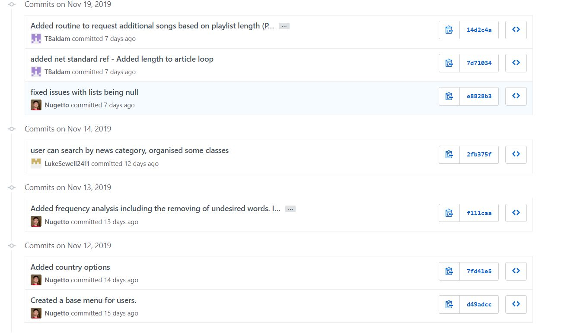

This screenshot shows the latest commits to the GitHub repository by all members of the group. Each commit had a title to show what was added so we could go back to a version if the current application didn’t work. This is a big benefit to using a software engineering tool like GitHub as the version control aspect is crucial when multiple users are modifying the code, because a new version that gets committed could be full of errors and if we didn’t have multiple versions then we would have to try and fix someone else’s code which would be quite difficult depending on what is added.

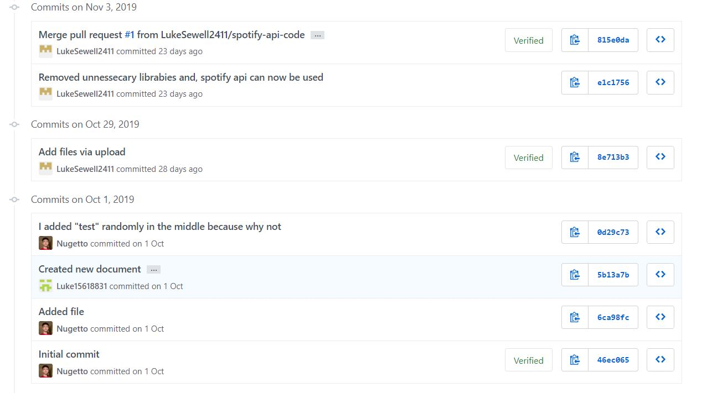

Screenshot 2 from the commit log.

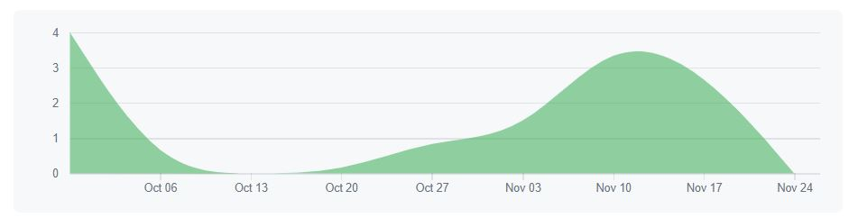The contribution log shows the commits and what all the members contributed in the entire process.

For the creation of the project, GitHub has been a vital tool, and therefore it’s a leading software development tool as It allows multiple users to download code and work on extra features and push the latest edition. This can also be moderated by a few users for a much bigger community project as anyone can access the code but only certain commit will be accepted so the code isn’t inundated with commits causing the main developer to have to go back to a version from a while ago. It can be used for small or big projects and is free to access meaning it’s a popular versioning tool. GitHub can also facilitate Scrum well as it can easily be used in code reviews in the scrum review as you can access the latest version and test it and let the development team know during the retrospective. The ability to keep the project locked to a select number of members or keep it open to anyone is also a good feature for scrum as you will want to lock the access to the code to your development team, for the security of the project.

For a big team, the cost of using all of the GitHub features can be costly and can add up. A development team with internal servers could use their own Git to keep all of the documents rather than using GitHub. Another drawback is the potential security as GitHub has had data breaches in the past and for a development team this could be risky as you could lose all of your data and the clients would be enraged with you for not having their project in the highest of security.

Google Drive:

Google drive is a cloud-based file storage service that we used to store all of the Microsoft Word documents during the project as well as the PowerPoint presentation for week 7. We decided to use both this and GitHub to store file as we wanted to keep the application and documentation separate as it helped the team during the whole process. I also updated the sprint log document after each sprint review and uploaded it in the google drive so everyone could access the document for the meeting during the workshop and be able to add anything they thought was needed or missing.

Google drive could be used for small scale development projects as multiple users can access the documents and edit them at the same time which is very helpful in brainstorming and group discussions which happens during the sprint reviews and stand-up meetings and could be utilised quite well for storing documents as it has a good level of security.

For a large-scale project, it wouldn’t be as useful due to the fact it is more informal than a development service like GitHub or Trello which is more of a software development tool.

Facebook Messenger:

Facebook messenger is a messaging application created by Facebook. We utilised it as every member of the group had the app which made messaging each other about updates to meetings and when we had completed work etc into a group chat. This was beneficial to a small-scale project for a group of university students as we needed to get access to each other, and Messenger was the easiest way to do this. For other larger scale projects or for a project in industry this wouldn’t be professional enough as the messages could be accessed as Facebook Messenger has been hacked and messages have been accessed before and the security of this application is probably not good enough for a company in industry to use and they would either use an encrypted service or meet in person especially if they are all working in an office type setting together.

Visual Studio:

This IDE was very useful in the project development as it’s a very streamlined package that has great features to show you errors with a red line under them and tries to help you rectify the problem. I have used it in previous projects at university and it is good for everything we wanted it to be and supports C# which is what we wrote the application in. The APIs worked very well with Visual Studio and the documentation on the websites were easy to follow to get started in the first 2 sprints. It can be used in small- or large-scale projects as it is fully supported by Microsoft so can help develop any type of application you would like with the ability to use many different libraries and plug-ins which you can download and use. It is used in industry quite often by many companies so that is why we used it.

**Group Evaluation:**

|  |  |
| --- | --- |
| Group Member | Contribution Percentage |
| Harry Langham | 100% |
| Luke Sewell | 100% |
| Callum King | 100% |
| Suki Harrison | 10% |
|  |  |

The group members in total were very good and most worked very well for the entire project. Luke and Callum helped program the application with me as well as helping to complete the sprint reviews and other sprint log features. They were always able to be contacted for stand-up meetings and additional meetings whenever was needed. Suki did not attend any workshops or meetings until right at the end but did help solve a few errors in the final version of the application, so I have given her 10% contribution.

**References:**

What is Scrum? 2019

[Online] Available at: <https://www.scrum.org/resources/what-is-scrum> [Accessed 22 November 2019]

What is a sprint in Scrum? 2019

[Online] Available at: <https://www.scrum.org/resources/what-is-a-sprint-in-scrum> [Accessed 22 November 2019]

GitHub 2019

[Online] Available at: <https://searchitoperations.techtarget.com/definition/GitHub> [Accessed 23 November 2019]